DATE: 29.07.2018
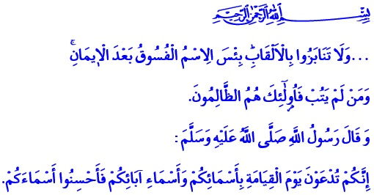
GIVING A BEAUTIFUL NAME – ONE OF THE RIGHTS OF CHILDREN ON PARENTS
Jumu’ah Mubarak Dear Brothers and Sisters!
Our Prophet (s.a.w) attached great importance on paying regard to Islamic values at every step of life. Because, he was a Prophet, sent to us to teach the awareness of servitude, grace and elegance. His sensitivity to make each moment of his life meaningful manifested itself even in naming babies. Such that he named his two beloved grandsons Hasan and Husain, meaning beautiful, graceful and nice. While doing this, he first embraced them with affection. Then he recited the Adhan to their right ears, and Iqamah to their left ears. And he prayed for these babies to have a benevolent and blessed life.
Brothers and Sisters!
With that Adhan and Iqamah, our Prophet (s.a.w) was actually whispering the purpose of life to the ears of the baby. He was preaching faith and Islam, in short, tawhid to him. He was teaching that he should be a servant to only Allah throughout his life. The Messenger of Allah (s.a.w) was giving a direction for the baby with the nice and meaningful name he gave. He was advising to be in the service of benevolence and goodness all his life.
Honorable Believers!
As expressed in the Qur’an, our children are the light of our eyes, and the felicity of our hearts. They are both a blessing and a trust of our Lord to us. Every baby is special and every baby is dear regardless of their sex. Allah created him as the most honorable creature and His vicegerent on earth, and entrusted to us, adults. This baby, for whom we will work so that he can be a peaceful servant and a good person, deserves a proper welcome. One of the first steps in this welcoming is giving him a beautiful name.
Brothers and Sisters!
As babies start to know the worldly blessings in his mother’s arms, he also acquires an identity with his name that will reach towards the eternal life. Our Prophet (s.a.w) said, “On the Day of Resurrection you will be called by your names and by your father's names, so give your children good names.”

This hadith teaches us that people deserve names which have a beautiful pronunciation and a beautiful meaning. As much as people’s bodies, dignity and honor are respectable, their names are also respectable, and deserve esteem. Let alone giving a person a name which he will dislike all his life, even calling someone with an offensive nickname is forbidden in our religion. Our Lord Almighty warns us in this issue as, “Do not call each other by [offensive] nicknames.”
Estimable Muslims!
Names are the reflections of a faith, a civilization, and a culture. The importance attached by our civilization, inspired by the perspicuous religion of Islam, is obvious. Our nation have taken pride in giving children the names of great people, who put their stamps on history, our Prophet being in the first place.
In our tradition, a name is, first of all, a factor that reminds a person of his value as a human being, the meaning of his existence, and his civilization. Sounding nice alone is not a name’s worth. It should also have a meaning that will reach the bearer to moral perfection and a high personality. In this sense, our Prophet changed the names that disregarded the Islamic faith and personal dignity, and connotated violence and hatred.
Brothers and Sisters!
Let us give our children meaningful names that is suited for our religious and national values, and that will remind them at all times that they are Muslims. Let us not forget that as much as we are responsible for feeding and educating them, we are also responsible for giving them beautiful names. Let us remember that names contradicting our faith and culture will destroy their world of values. Let us give our children names, which instill in them morality, good manners, awareness and ideals, and navigate them like a compass to goodness, beauty, and benevolence throughout their lives.

Bukhari, Manaqib al-Ansar, 45; Adab, 109; Adab al-Mufrad, 286.
Abu Dawud, Adab, 61.
Hujurat, 49/11. General Directorate of Religious Services

